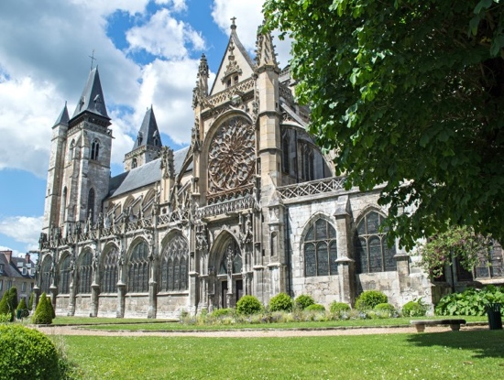
Paris & the Seine Valley to Normandy Cruise
November 7 – 18, 2021
8 Days | 4 Cities | 1 Country

Cultural Adventures: Tours for the Young-at-Heart

Begin your Teeming River Cruise in Paris—the city of lights! Its seductive charms are legendary as it boasts world-class museums, inviting sidewalk cafes, gleaming boutiques, glorious food and iconic architecture. After getting situated on the MS Botticelli your first stop is the charming town of Vernon. From Vernon you’ll cruise down the Seine for stops at Rouen, Honfleur, before returning to Paris. Complete your Teeming River Cruise in Paris, a beautiful, history-rich and tasty place to explore! Perhaps add an additional day or two to your trip to enjoy the city.
Trip Itinerary

Day 1 – Sunday, November 7, 2021 - Paris, France – You’ll arrive a day before the cruise begins for a chance to relax and meet your fellow travelers. Hotel in Paris

Day 2 - Monday, November 8, 2021 - Paris, France - Day free for you to explore the museums, cafes and walks of Paris on your own. Check in for your cruise on the MS Botticelli will begin at 5 pm. B, D
Day 3 – Tuesday, November 9, 2021 – Vernon, France A charming little town with centuries-old half-timbered houses and countryside chateau painted by Claude Monet.
Day 4 Wednesday, November 10, 2021 - Rouen, France - In Rouen, an important medieval city, you can still see many medieval landmarks especially around the old city. One of the most interesting sights is the 4th century La Cathédral de Rouen, which has an especially high bell tower.

Day 5 - Thursday, November 11, 2021 - Honfleur, France - Honfleur is a town surrounding a beautiful little 17th-century harbor in Lower Normandy. It is especially known for its old, beautiful picturesque port, characterized by its houses with slate-covered frontages, painted many times by artists.
Day 6 – Friday, – November 12, 2021 - Rouen, France -
Day 7 - Saturday, November 13, 2021 - Rouen France In Rouen, the site of Joan of Arc’s imprisonment and death, the new and very attractive Joan of Arc church with extensive modern stained glass offers a peaceful place to meditate.

Day 8 – Sunday, November14, 2021 – Paris - Enjoy breakfast before disembarking at 9 am.

Double occupancy cost for each person includes the cruise, Paris hotel, Port Taxes and Fees. Prices are for the trip only. International flights are not included

- Double Cabins Lower Deck – $1895 per person
- Double Cabins Upper Deck – $1995 per person.

Let me know if you are interested in receiving additional information and a notice of when a deposit is due. If you are ready to reserve a cabin a $75 refundable payment is required.
Contact Connie at 317 908 1220 or cchamp@culturaladventures.info with questions and for more information
www.culturaladventures.info

